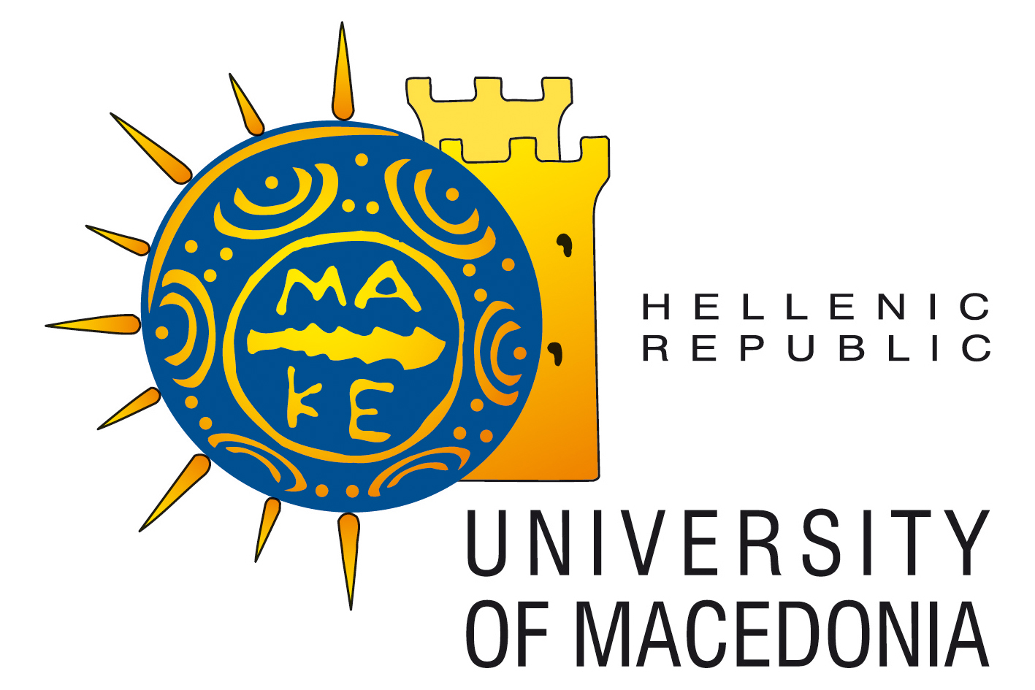

Kick-Off Meeting AGENDA
University of Macedonia (UOM)
Thessaloniki (Greece)
VENUE: Conference Room at UOM

Tuesday 11th February 2014

17:00-17:30 | Registration of the participants,  Entrance Hall- Conference room of the University of Macedonia
17:30-17:45 | Opening and welcome speeches
17:45-19:00 | Project overview and planning K. Papadopoulos, UOM  - Short presentation of the Partners  - University of Macedonia (UOM) – L. Kartasidou, UOM  - Karlsruher Institut für Technologie (KIT) - Karin Mueller  - University of Athens (UOA) - Georgios Kouroupetroglou  - GEOIMAGING Ltd (GEO) - Stratos Stylianidis  - Mustafa Kemal University (MKU) - Suad Sakallı Gümüş
19:00-19:30 | Discussion
19:30 | Welcome Dinner

Wednesday 12th February 2014
09:30-11:30 | Activities and tasks of the 1st project year (Part I)  - WP2 Development of audio-tactile symbols – K. Papadopoulos, UOM
11:30-12:00 | Discussion
12:00-13:00 | Coffee and Lunch break, Entrance hall – Conference room
13:00-14:30 | Activities and tasks of the 1st project year (Part II)  - WP3 Development of audio-tactile material – G. Jaworek & K. Mueller, KIT  - WP4 Training activities - G. Kouroupetroglou, UOA  - WP5 Quality Assurance – St. Stylianidis & K. Smagas, GEO  - WP6 Dissemination - Suad Sakallı Gümüş MKU  - WP7 Exploitation of results – K. Smagas & St. Stylianidis, GEO
14:30-15:00 | Coffee break, Entrance hall – Conference room
15:00-16:30 | WP1 Project Management: Administrative and financial aspects of the project – K. Papadopoulos, & L. Kartasidou, UOM  - Remarks from the evaluation form  - Internal Partnership Agreement  - Procedure for collecting valid documentations
16:30-17:00 | Overall discussion
17:30 | End of the meeting

